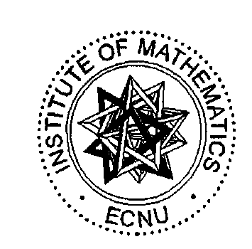
The 10th Anniversary (1994-2004) Conference for the Institute of Mathematics, ECNU & International Conference on Complex Geometry and Related Theories
June 21-25, 2004, Shanghai, China
Sponsor:
East China Normal University, Shanghai
Magnolia Science & Technology Talent Fund, Science & Technology Commission of Shanghai Municipality, Shanghai
Organizing Committee:
Stephen S T Yau（Chairman，University of Illinois at Chicago, USA, Institute of Mathematics，ECNU, China. E-mail: yau@uic.edu ）
Shengli Tan（Institute of Mathematics，ECNU. E-mail: sltan@math.ecnu.edu.cn ）
Zhijie Chen（Department of Mathematics，ECNU, China. E-mail: zjchen@math.ecnu.edu.cn ）
Jian-yi Shi（Institute of Mathematics，ECNU, China. E-mail: jyshi@math.ecnu.edu.cn ）
Musheng Wei（Institute of Mathematics，ECNU, China. E-mail: mwei@math.ecnu.edu.cn ）
Deming Zhu（Department of Mathematics，ECNU, China. E-mail: dmzhu@math.ecnu.edu.cn ）
Feng Zhou（Department of Mathematics，ECNU, China. E-mail: fzhou@math.ecnu.edu.cn ）
Chunli Shen（Institute of Mathematics，ECNU, China. E-mail: cshen@math.ecnu.edu.cn ）
Jianping Lu（Department of Mathematics，ECNU, China. E-mail: jplu@math.ecnu.edu.cn ）
Lei Lin（Secretary，Institute of Mathematics，ECNU, China. E-mail: llin@math.ecnu.edu.cn ）
Place:
New Shaw Building (in the Campus) & JinShajiang Hotel, Shanghai
There will be two types of lectures: invited lectures and contributed lectures. The following is the list of the confirmed invited speakers.
Roger W. Brockett (Harvard University, USA), E-mail: brockett@yellowstone.hrl.harvard.edu
Fabrizio Catanese (University of Bayreuth, Germany), E-mail: Fabrizio.Catanese@uni-bayreuth.de
Gerard Jennhwa Chang (Taiwan University, Taiwan), E-mail: gjchang@math.ntu.edu.tw
Guantao Chen (Georgia State University, USA), E-mail: matgtc@langate.gsu.edu
Yongchuan Chen (Nankai University，China), E-mail: chenstation@yahoo.com
Ben Chow (University of California, San Diego ,USA) (E-mail: benchow@math.ucsd.edu
Zhiqiang Gao (Cleveland State University, USA), E-mail: z.gao@csuohio.edu
Bei Hu (University of Notre Dame, USA), E-mail: blhu@nd.edu
Xiaojun Huang (Rutgers University, USA), huangx@math.rutgers.edu
Shanyu Ji (University of Houston, USA), E-mail: shanyuji@ld41.math.uh.edu
Ming-Chang Kang (Taiwan University, Taiwan), E-mail: kang@math.ntu.edu.tw
Hong-Jian Lai (West Virginia University, USA), E-mail: hjlai@math.wvu.edu
Song-Ying Li (University of California, Irvine, USA), E-mail: sli@math.uci.edu
Huaxin Lin (ECNU, China, University of Oregon, USA), E-mail: hxlin@noether.uoregon.edu
Kefeng Liu (UCLA, USA), E-mail: liu@math.ucla.edu
Hong-Wen Lu（Tongji University，China）, E-mail: lu-hongwen@163.com
Xi-nan Ma (ECNU, China), E-mail: xnma@math.ecnu.edu.cn
Ngaiming Mok (Hong Kong University, HK), E-mail: nmok@hkucc.hku.hk
Lei Ni (University of California, San Diego, USA), E-mail: lni@math.ucsd.edu
Hourong Qin (Nanjing University, China), E-mail: hrqin@nju.edu.cn
Jian-yi Shi (ECNU, China), E-mail: jyshi@math.ecnu.edu.cn
Yum-Tong Siu (Harvard University, USA), E-mail: siu@math.harvard.edu
Shengli Tan (ECNU, China), E-mail: sltan@math.ecnu.edu.cn
Gengsheng Wang (Central China Normal University, China), E-mail: cocdm1@ccnu-1.ccnu.edu.cn
Jiaping Wang (University of Minnesota, USA), E-mail: jiaping@math.umn.edu
Sid Webster (University of Chicago, USA), E-mail: webster@math.uchicago.edu
Nanhua Xi (Chinese Academy of Sciences, China), E-mail: nanhua@mail2.math.ac.cn
Shi-Jian Yan (Beijing Normal University, China), E-mail: yansj@bnu.edu.cn
Shing-Tung Yau (Harvard University, USA), E-mail: yau@math.harvard.edu
Stephen S T Yau (University of Illinois at Chicago, USA, ECNU, China)，E-mail: yau@math.uic.edu
Xingxing Yu (Georgia Institute of Technology, USA), E-mail: yu@math.gatech.edu
Xiangyu Zhou (Chinese Academy of Sciences, China), E-mail: xyzhou@mail2.math.ac.cn
Program:
The Scientific program will be held from Monday, June 21 to Friday, June 25, 2004. The program will include 60 minutes invited talks and 45 minutes contributed talks.
Registration forms and abstracts should be received by April 20, 2004.

Accommodation:
Accommodation is available at New Shaw Building. The cost is about US$ 40 per night per person in a single/double room with a shower.
Ways of arrival and time of reception
The hotel’s information desk will start to work at 2:00pm to 8:00pm on June 20, 2004. The serve don’t stop until the end of the conference.
By air: Arrival at the Hongqiao airport or Pudong airport , the time of engagement: 9:00am to 22:00pm on June 20.
By train: Train stops at Shanghai train station, about 8 kilometers from East China Normal University. You can take a taxi, it is about 20 to 30 minutes to the hotel, the fare is about 25 Yuan. The time of engagement: 13:00pm to 20:00pm on June 20.
Concern web:
You will find all current information about our conference on the World Wide Web at
http://www.math.ecnu.edu.cn/
Linkman:
Lei Lin, Tel: (021)-62232366, E-mail: llin@math.ecnu.edu.cn
The following is the campus map

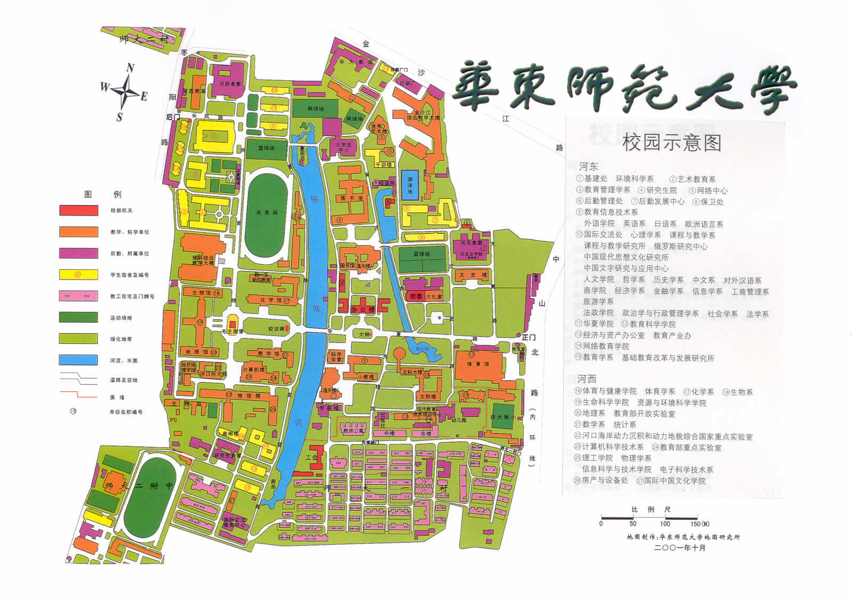

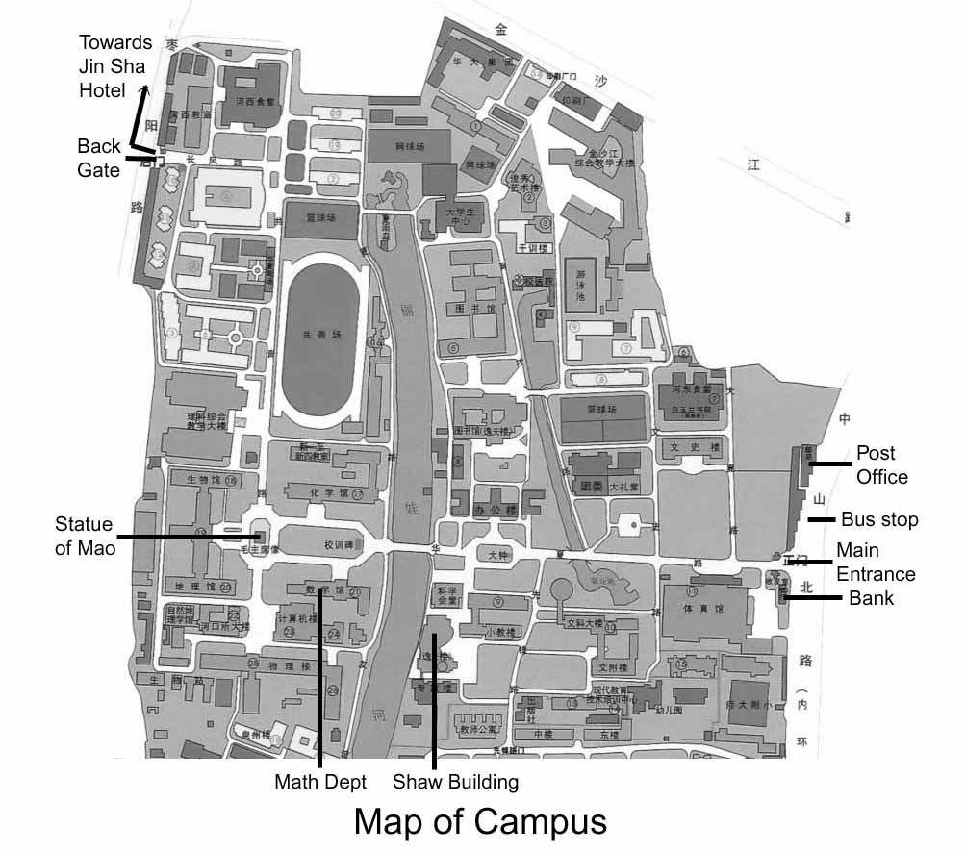

华东师范大学数学研究所建所10周年大会暨
复几何及相关的数学理论国际会议
6..21-25，2004 上海 中国

主办单位：
华东师范大学数学研究所
赞助单位：
华东师范大学
上海市科学技术委员会白玉兰基金
组委会成员名单：
丘成栋（主席，University of Illinois at Chicago, 美国, 华东师范大学数学研究所，中国. E-mail: yau@uic.edu ）
谈胜利（华东师范大学数学研究所，中国. E-mail: sltan@math.ecnu.edu.cn ）
陈志杰（华东师范大学数学系，中国. E-mail: zjchen@math.ecnu.edu.cn ）
时俭益（华东师范大学数学研究所，中国. E-mail: jyshi@math.ecnu.edu.cn ）
魏木生（华东师范大学数学研究所，中国. E-mail: mwei@math.ecnu.edu.cn ）
朱德明（华东师范大学数学系，中国. E-mail: dmzhu@math.ecnu.edu.cn ）
周 风（华东师范大学数学系，中国. E-mail: fzhou@math.ecnu.edu.cn ）
沈纯理（华东师范大学数学研究所，中国. E-mail: cshen@math.ecnu.edu.cn ）
卢建平（华东师范大学数学系，中国. E-mail: jplu@math.ecnu.edu.cn ）
林 磊（秘书，华东师范大学数学研究所，中国. E-mail: llin@math.ecnu.edu.cn ）

联系人：
林 磊, Tel: 021-62232366, E-mail: llin@math.ecnu.edu.cn
下榻宾馆：
中学校长培训中心（新逸夫楼，华东师范大学校园内）, 金沙江宾馆, 上海 中国
被邀请的报告人：
报告分两种形式：特邀报告和专题报告。以下为已确认的邀请人名单。
Roger W. Brockett (Harvard University, USA), E-mail: brockett@yellowstone.hrl.harvard.edu
Fabrizio Catanese (University of Bayreuth, Germany), E-mail: Fabrizio.Catanese@uni-bayreuth.de
Gerard Jennhwa Chang (张镇华) (Taiwan University, Taiwan),
E-mail: gjchang@math.ntu.edu.tw
Guantao Chen (陈冠涛) (Georgia State University, USA), E-mail: matgtc@langate.gsu.edu
Yongchuan Chen (陈永川) (南开大学, 中国), E-mail: chenstation@yahoo.com
Ben Chow (University of California, San Diego, USA) (E-mail: benchow@math.ucsd.edu
Zhiqiang Gao (高志强) (Cleveland State University, USA), E-mail: z.gao@csuohio.edu
Bei Hu (胡钡) (University of Notre Dame, USA), E-mail: blhu@nd.edu
Xiaojun Huang (Rutgers University, USA), huangx@math.rutgers.edu
Shanyu Ji (University of Houston, USA), E-mail: shanyuji@ld41.math.uh.edu
Ming-Chang Kang (康明昌) (Taiwan University, Taiwan), E-mail: kang@math.ntu.edu.tw
Hong-Jian Lai (赖虹建) (West Virginia University, USA), E-mail: hjlai@math.wvu.edu
Song-Ying Li (University of California, Irvine, USA), E-mail: sli@math.uci.edu
Huaxin Lin (林华新) (ECNU, China, University of Oregon, USA), E-mail: hxlin@noether.uoregon.edu
Kefeng Liu (刘克峰) (UCLA, USA), E-mail: liu@math.ucla.edu
Hong-Wen Lu (陆洪文)（同济大学，中国）, E-mail: lu-hongwen@163.com
Xi-nan Ma (麻希南) (华东师范大学，中国), E-mail: xnma@math.ecnu.edu.cn
Ngaiming Mok (莫毅明) (Hong Kong University, HK), E-mail: nmok@hkucc.hku.hk
Lei Ni (University of California, San Diego, USA), E-mail: lni@math.ucsd.edu
Hourong Qin (秦厚荣，南京大学，中国), E-mail: hrqin@nju.edu.cn
Jian-yi Shi (时俭益) (华东师范大学，中国), E-mail: jyshi@math.ecnu.edu.cn
Yum-Tong Siu (萧荫棠) (Harvard University, USA), E-mail: siu@math.harvard.edu
Shengli Tan (谈胜利)(华东师范大学，中国), E-mail: sltan@math.ecnu.edu.cn
Gengsheng Wang (汪更生) (华中师范大学，中国), E-mail: cocdm1@ccnu-1.ccnu.edu.cn
Jiaping Wang (王嘉平) (University of Minnesota, USA), E-mail: jiaping@math.umn.edu
Sid Webster (University of Chicago, USA), E-mail: webster@math.uchicago.edu
Nanhua Xi (席南华) (中国科学院数学所，中国), E-mail: nanhua@mail2.math.ac.cn
Shi-Jian Yan (严士健) (北京师范大学，中国), E-mail: yansj@bnu.edu.cn
Shing-Tung Yau (丘成桐) (Harvard University, USA), E-mail: yau@math.harvard.edu
Stephen S T Yau (丘成栋) (University of Illinois at Chicago, USA, 华东师范大学,中国)，E-mail: yau@math.uic.edu
Xingxing Yu (郁星星) (Georgia Institute of Technology, USA), E-mail: yu@math.gatech.edu
Xiangyu Zhou (周向宇) (中国科学院数学所，中国), E-mail: xyzhou@mail2.math.ac.cn
活动安排：
本次科研活动将于2004年6月21日（星期一）至25日（星期五）举办。活动包括1小时特邀报告和45分钟专题报告。
食宿安排:
食宿将安排在新逸夫楼。使用带有淋浴的标准单人/双人间。
社会事务：
会议期间视客人兴趣安排一次市内观光旅行。
到达方式与接待时间：
中学校长培训中心 (新逸夫楼) 将于2004年6月20日下午2点至8点开始接待，直至会议结束。
飞机：上海虹桥飞机场，出租车20～30分钟到达，路费大约35元。上海浦东飞机场，可乘航空专线到静安寺，再乘出租车或公交94路。
火车：上海火车站距离华东师范大学大约8公里。你可以选择出租车20～30分钟到达，路费大约25元。

